📄 Test Case: TC49_LodgetheOutwardBill
❌ FAILED:
[2026-02-20 15:19:54] ? Error: General Details
[2026-02-20 15:19:54] ? Assertion Failure: Test failed: General Details
↳ Reason: ❌ ❌ Assertion Failure: Test failed: General Details

📸 Screenshot:
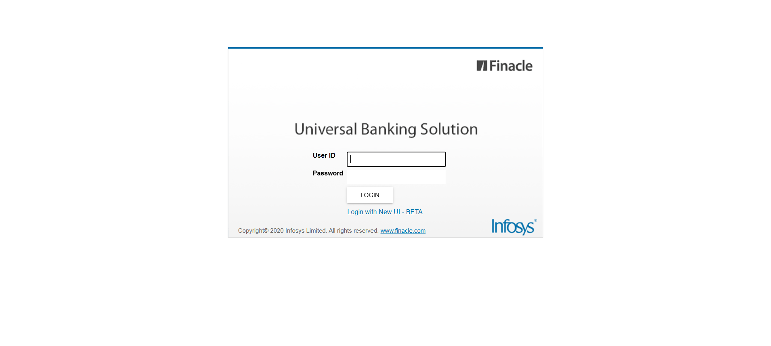
============================================================
📊 Suite Summary: Test
===============================================
Test
Total tests run: 1, Passes: 0, Failures: 1, Skips: 0
===============================================
⏱️ Total Duration: 01 min 25 sec

